ASSIGNMENT-3

|  |  |
| --- | --- |
| TEAM ID | PNT2022TMID49640 |
| PROJECT NAME | NUTRITION ASSISTANT APPLICATION |
| NAME | JOSEPHIN DERIN E |
| ROLL NO | 950019106017 |

1.Create a Bucket in IBM object storage. 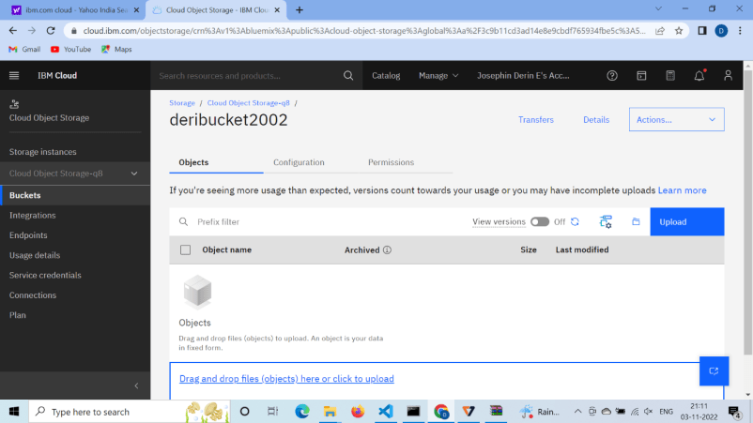

2,Upload 5 images to ibm object storage and make it public. Write html code to displaying all the 5 images.

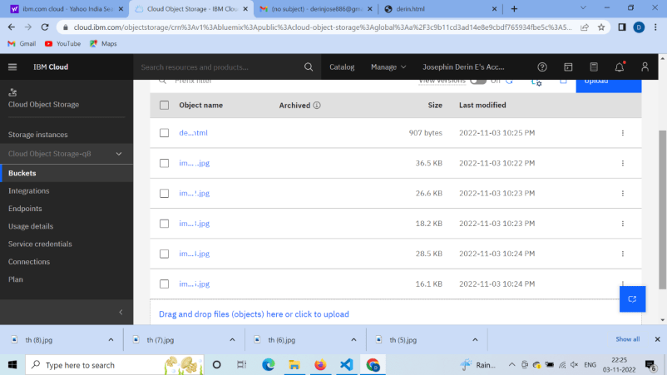

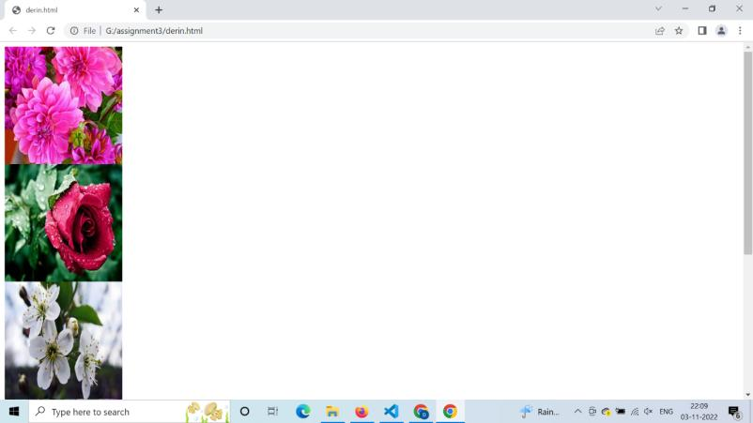

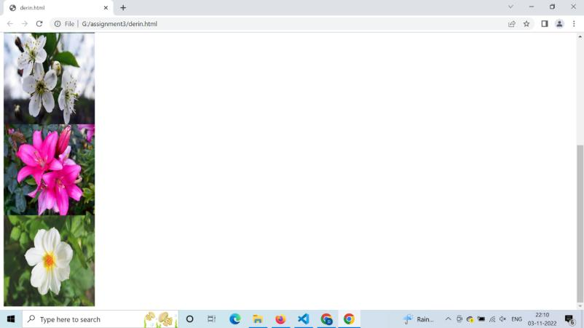

derin.html

<html>

<head>

<link rel="stylesheet" href="style.css">

</head>

<body>

<div class="row">

<div class="column">

<img src="C:\Users\dell\OneDrive\Desktop\object storage\image1.jpg" alt="Disable" style="width: 200px;height: 200px;">

</div>

<div class="column">

<img src="C:\Users\dell\OneDrive\Desktop\object storage\image2.jpg" alt="Disable" style="width: 200px;height: 200px;">

</div>

<div class="column">

<img src="C:\Users\dell\OneDrive\Desktop\object storage\image3.jpg" alt="Disable" style="width: 200px;height: 200px;"> </div>

<div class="column">

<img src="C:\Users\dell\OneDrive\Desktop\object storage\image4.jpg" alt="Disable" style="width: 200px;height: 200px;">

</div>

<div class="column">

<img src="C:\Users\dell\OneDrive\Desktop\object storage\image5.jpg" alt="Disable" style="width: 200px;height: 200px;">

</div>

</div>

</body>

</html>

3.Upload a css page to the object storage and use the same page in your HTML code

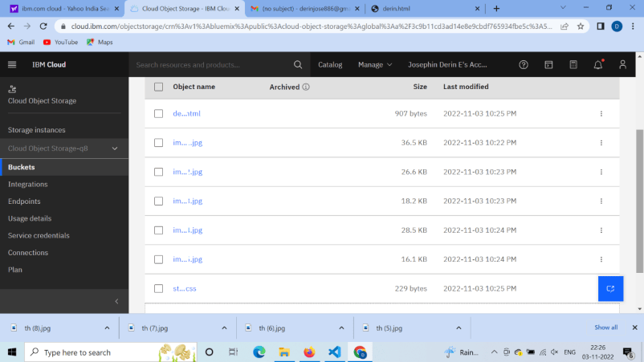

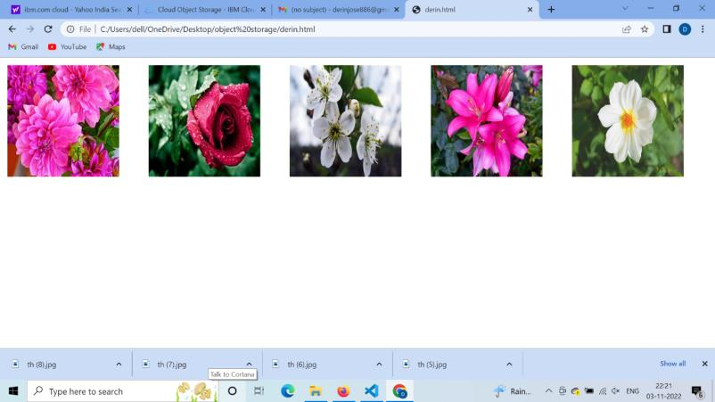

Style.css

.column {

float: left; width: 33.33%; padding: 5px;

}

.row::after {

content: "";

clear: both;

display: table; }

.row { display:

flex; }.column

{ flex: 33.33%;

padding: 5px;

}

4.Design a chatbot using IBM Watson assistant for hospitals. Ex: User comes with a query to know the branches for that hospital in your city. Submit the web URL of that chatbot as an assignment.

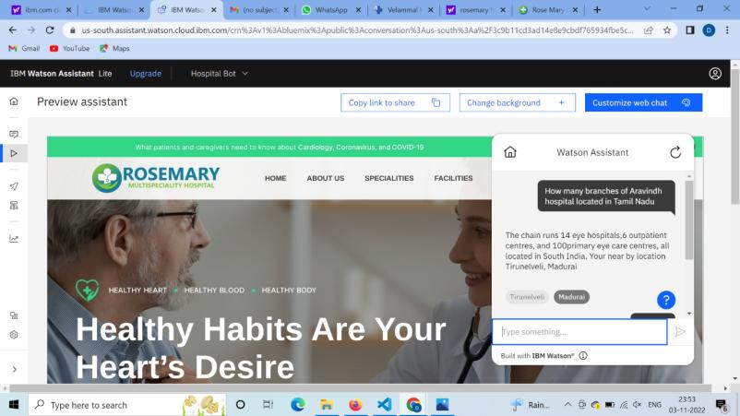

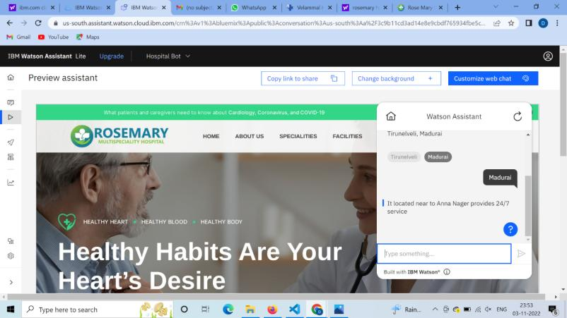

5. Create Watson Assistant service with 10 steps and use 3 conditions in it. Load that script in the HTML page.

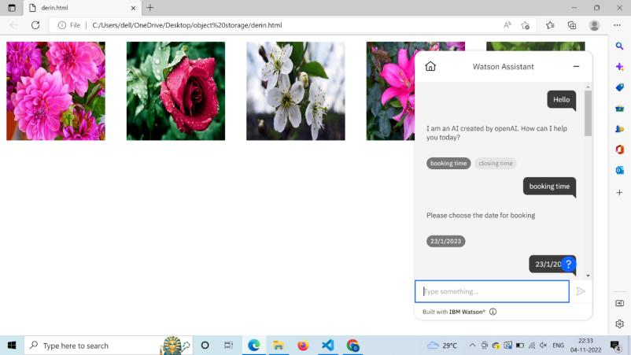

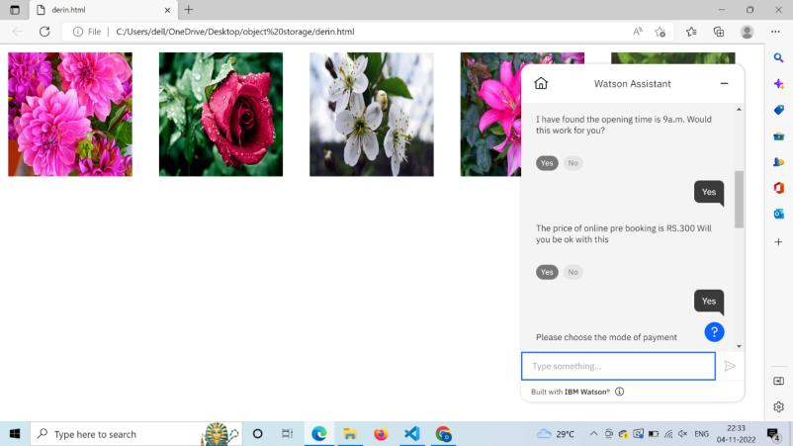

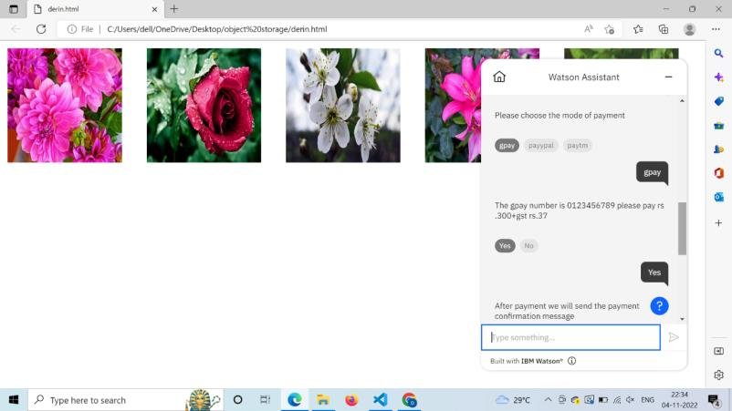

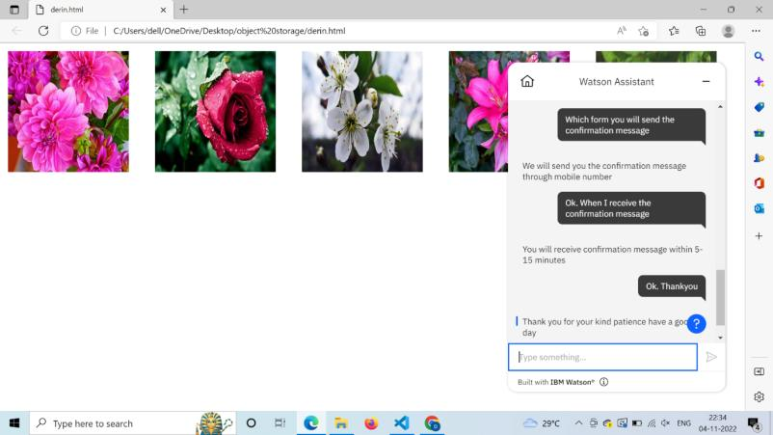

derin.html

<html>

<head>

<link rel="stylesheet" href="style.css">

</head>

<body>

<div class="row">

<div class="column">

<img src="C:\Users\dell\OneDrive\Desktop\object storage\image1.jpg" alt="Disable" style="width: 200px;height: 200px;">

</div>

<div class="column">

<img src="C:\Users\dell\OneDrive\Desktop\object storage\image2.jpg" alt="Disable" style="width: 200px;height: 200px;">

</div>

<div class="column">

<img src="C:\Users\dell\OneDrive\Desktop\object storage\image3.jpg" alt="Disable" style="width: 200px;height: 200px;"> </div>

<div class="column">

<img src="C:\Users\dell\OneDrive\Desktop\object storage\image4.jpg" alt="Disable" style="width: 200px;height: 200px;">

</div>

<div class="column">

<img src="C:\Users\dell\OneDrive\Desktop\object storage\image5.jpg" alt="Disable" style="width: 200px;height: 200px;">

</div>

</div>

</body>

<script>

window.watsonAssistantChatOptions = {

integrationID: "946c8761-a5d6-4717-97a8-b97654bccb29", // The ID of this integration.

region: "us-south", // The region your integration is hosted in.

serviceInstanceID: "d19e2ed5-5cca-419d-a280-fba5ba31567a", // The ID of your service instance.

onLoad: function(instance) { instance.render(); }

};

setTimeout(function(){

const t=document.createElement('script');

t.src="https://web-chat.global.assistant.watson.appdomain.cloud/versions/" + (window.watsonAssistantChatOptions.clientVersion || 'latest') + "/WatsonAssistantChatEntry.js";

document.head.appendChild(t);

});

</script>

</html>